# Lab 11: Multiple Linear Regression (Chapter 6)

## Objectives

* Extend our knowledge about simple linear regression to multiple linear regression
* Use JMP to fit a linear model with multiple variables

## Multiple Linear Regression Models

Last week we focused on single linear regression models. This week, we move onto considering multiple linear regression models, in which we may have different levels of our response (y) variable (now denoted by yi, where i represents the different levels) and multiple factors (x) relating to that response.

$$y_{i}=β_{0}+β_{1}x_{i1}+β_{2}x_{i2}+…+ϵ_{i}$$

## For single linear regression model hypothesis testing, we were testing if our slope beta equaled zero; now, we test if ANY beta is non-zero, but it is not necessary that every term within the regression model is significant.

## Multiple Linear Regression in JMP

After loading your data in JMP, select Analyze > Fit Model.

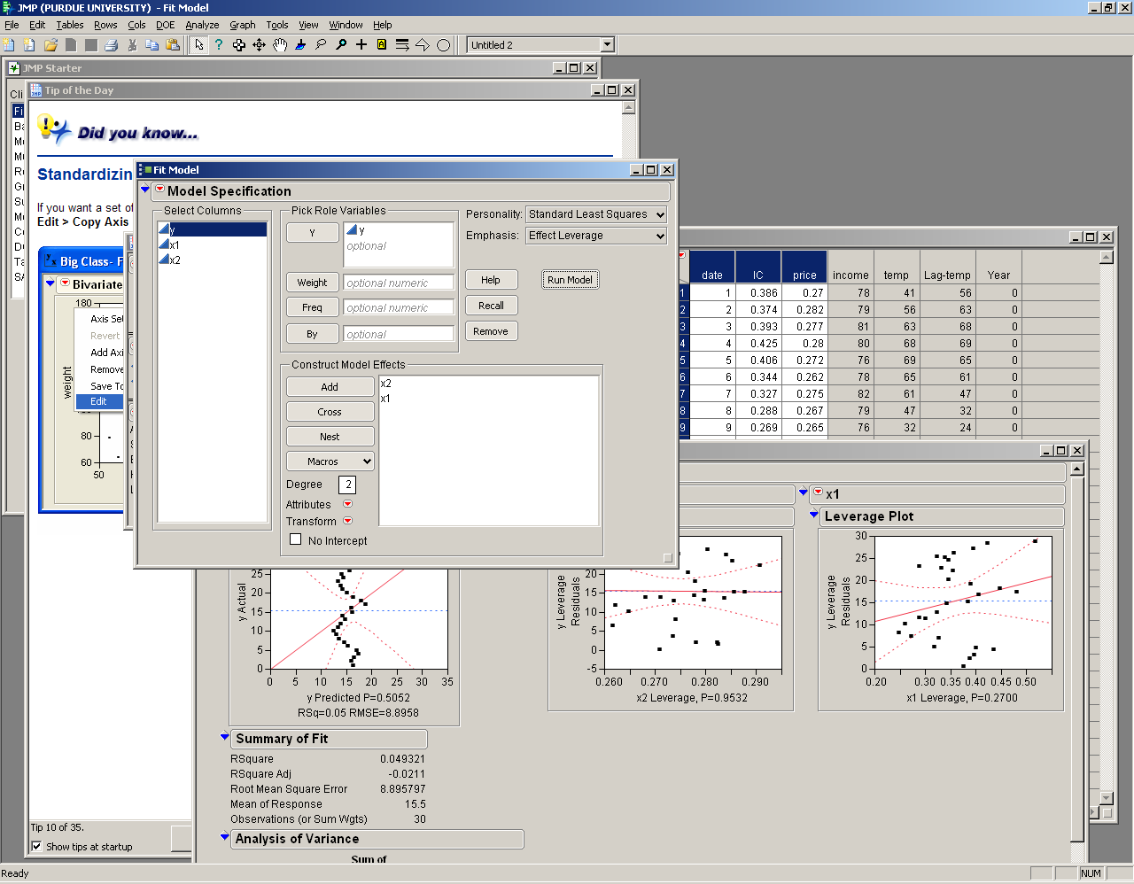

Put your response (y) variable into the Y box, and the factors (x) into the Construct Model Effects box. Now, click Run Model.

The output from this is generally the same as the outputs for a single linear regression; you get your Summary of Fit information, ANOVA, and Parameter Estimates. You also still save your residuals to check your assumptions. If you need more explanation on how to analyze the JMP outputs for regression or on how to check your assumptions, check Lab 10.

## Lab 11 Exercises

Ice cream consumption was measured over 30 four-week periods from March 18, 1951 to July 11, 1953. The purpose of the study was to determine if ice cream consumption depends on the variables price, income, or temperature. The variables Lag-temp and Year have been added to the original data, where Lag-temp is the average temperature of the week prior and Year is equal to the year of the study minus 1951.

For the data uploaded to Blackboard, consider the effects of the various factors on the consumption of ice cream.

1. State H0 and H1 formally and describe what they mean in your own words.
2. State any assumptions.
3. Use JMP to run the linear regression to determine if you can reject H0 or not.
4. Which fitting parameters (β's) are significant with α = 0.05?
5. Explain if your assumptions are valid using your residuals.